1. What are the key components D.R.Y?

Don’t. Repeat. Yourself.

1. In an ASP.NET Razor application, where is most appropriate to specify the validation rules?

In the Model Class

1. DataAnnotations can be applied to both class and property.
2. Name two DataAnnotations that were used for validation.

Required and StringLength

1. Why does the Price property not have the Required annotation?

Decimals are inherently required.

1. Run the app. Take a screen shot of Create Movie with various validation rules being violated.

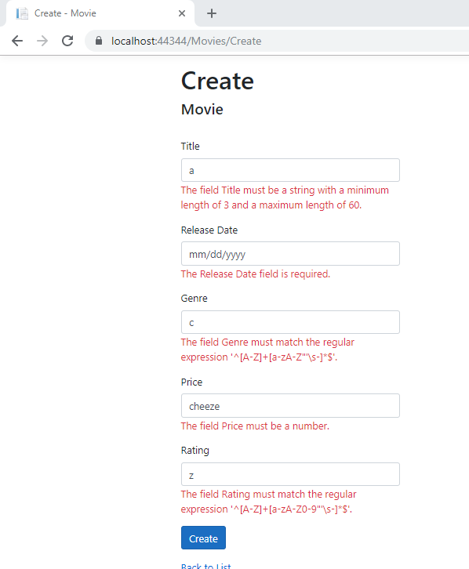

1. What two languages are being used on the client side to enforce any errors?

Javascript and JQuery

1. When does the form data actually get posted to the server?

Form data is only posted once there are no client-side verification errors.

1. What happens if the client browser has Javascript disabled?

Errors are enforced serverside.

1. Use the Validation link to answer the following questions:
   1. What two subsystems represent Model state?

Model Binding and Model Verification.

* 1. The user entering 56.78 in an integer field would fall into which of the above two subsystem types?

Model Binding

* 1. The user entering A when valid values are X, Y or Z would fall into which of the above two subsystem types?

Model Verification

* 1. What "flag" should be inspected to determine if any model errors are present?

ModelState.IsValid

* 1. What attribute is an option to using the "flag" from the prior question?

ApiController

* 1. Even though validation is automatic and handled by the controller, what method can be used to rerun validation programmatically?

TryValidateModel

1. What is the purpose of the attribute [Column(TypeName = "decimal(18, 2)")] for the Price property?

It is required to correctly map Price to currency in our database.

1. NOTE: To end this tutorial, the author states that DataAnnotation changes to the model results in changes to the schema, but will not cause Entity Framework to throw exceptions even though the schema is now out of sync with the database structure. But for good measure, it is recommended to prepare a migration for the changes.
2. Using SSOX, copy and paste the current CREATE TABLE of the Movie table.
3. CREATE TABLE [dbo].[Movie] (
4. [ID] INT IDENTITY (1, 1) NOT NULL,
5. [Title] NVARCHAR (MAX) NULL,
6. [ReleaseDate] DATETIME2 (7) NOT NULL,
7. [Genre] NVARCHAR (MAX) NULL,
8. [Price] DECIMAL (18, 2) NOT NULL,
9. [Ratings] NVARCHAR (MAX) NULL,
10. [Rating] NVARCHAR (MAX) NULL,
11. CONSTRAINT [PK_Movie] PRIMARY KEY CLUSTERED ([ID] ASC)
12. );
13. After running a migration, copy and paste the revised CREATE TABLE of the Movie table. Highlight the changes in yellow.
14. CREATE TABLE [dbo].[Movie] (
15. [ID] INT IDENTITY (1, 1) NOT NULL,
16. [Title] NVARCHAR (60) NOT NULL,
17. [ReleaseDate] DATETIME2 (7) NOT NULL,
18. [Genre] NVARCHAR (30) NOT NULL,
19. [Price] DECIMAL (18, 2) NOT NULL,
20. [Ratings] NVARCHAR (MAX) NULL,
21. [Rating] NVARCHAR (5) NOT NULL,
22. CONSTRAINT [PK_Movie] PRIMARY KEY CLUSTERED ([ID] ASC)
23. );